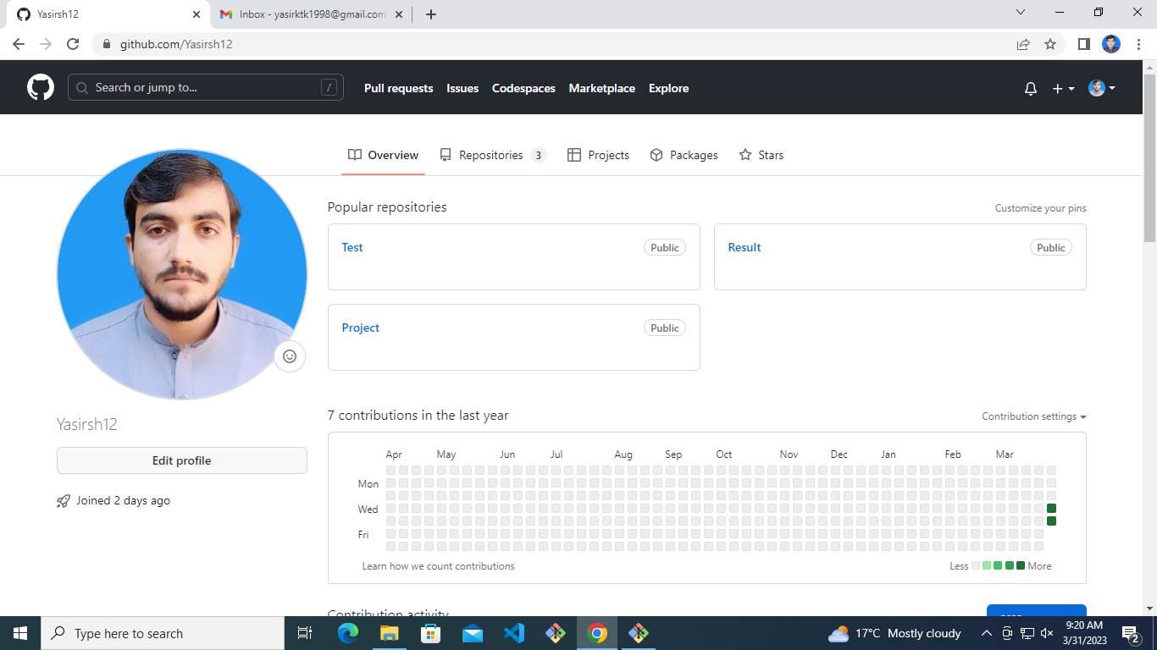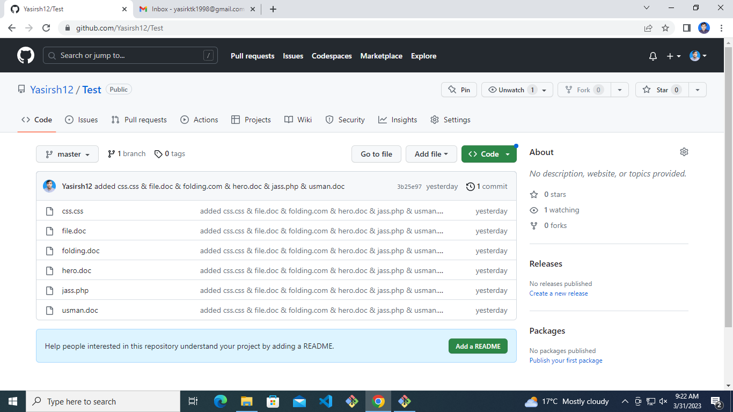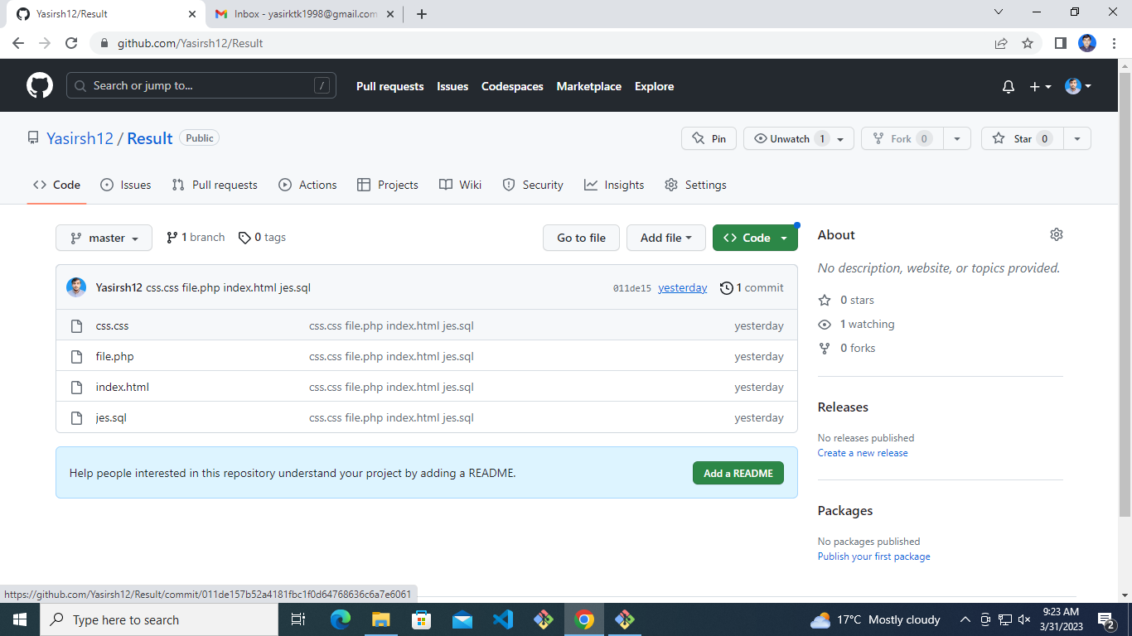

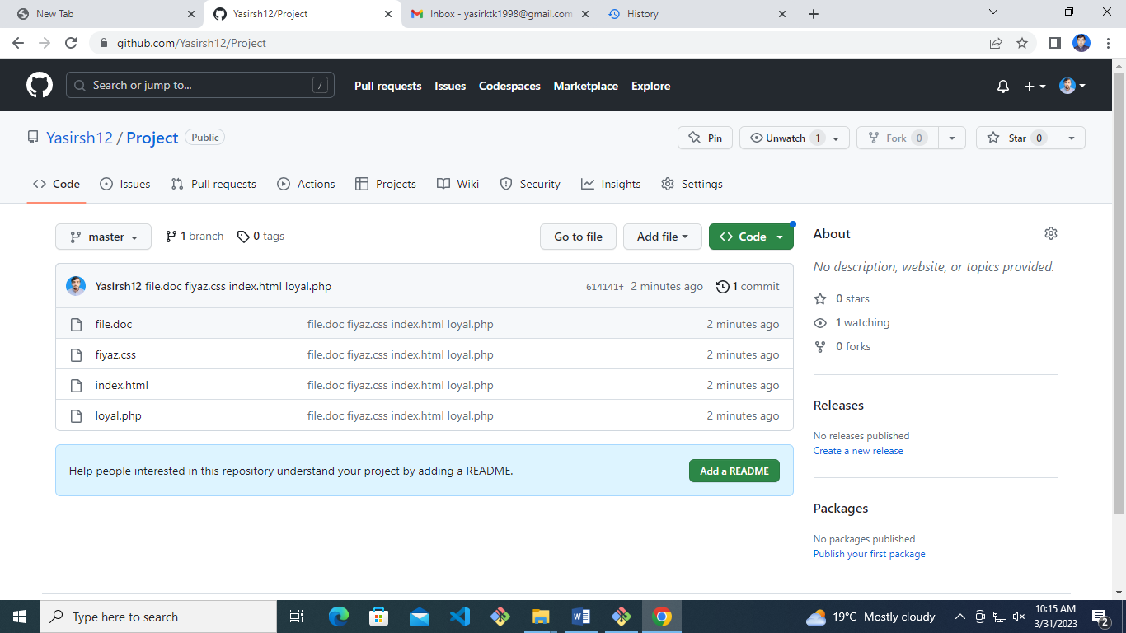

Administrator@DESKTOP-QT517IN MINGW64 ~

$ pwd

/c/Users/Administrator

Administrator@DESKTOP-QT517IN MINGW64 ~

$ ls

'3D Objects'/ Music/ Pictures/

AppData/ 'My Documents'@ PrintHood@

'Application Data'@ NTUSER.DAT Recent@

Contacts/ NTUSER.DAT{53b39e87-18c4-11ea-a811-000d3aa4692b}.TxR.0.regtrans-ms 'Saved Games'/

Cookies@ NTUSER.DAT{53b39e87-18c4-11ea-a811-000d3aa4692b}.TxR.1.regtrans-ms Searches/

Desktop/ NTUSER.DAT{53b39e87-18c4-11ea-a811-000d3aa4692b}.TxR.2.regtrans-ms SendTo@

Documents/ NTUSER.DAT{53b39e87-18c4-11ea-a811-000d3aa4692b}.TxR.blf 'Start Menu'@

Downloads/ NTUSER.DAT{53b39e88-18c4-11ea-a811-000d3aa4692b}.TM.blf Templates@

Favorites/ NTUSER.DAT{53b39e88-18c4-11ea-a811-000d3aa4692b}.TMContainer00000000000000000001.regtrans-ms Videos/

IntelGraphicsProfiles/ NTUSER.DAT{53b39e88-18c4-11ea-a811-000d3aa4692b}.TMContainer00000000000000000002.regtrans-ms ntuser.dat.LOG1

Links/ NetHood@ ntuser.dat.LOG2

'Local Settings'@ OneDrive/ ntuser.ini

Administrator@DESKTOP-QT517IN MINGW64 ~

$ cd Documents/

Administrator@DESKTOP-QT517IN MINGW64 ~/Documents

$ ls

'My Music'@ 'My Pictures'@ 'My Videos'@ VisualCode/ desktop.ini

Administrator@DESKTOP-QT517IN MINGW64 ~/Documents

$ cd VisualCode/

Administrator@DESKTOP-QT517IN MINGW64 ~/Documents/VisualCode (master)

$ ls

Class1/ project/

Administrator@DESKTOP-QT517IN MINGW64 ~/Documents/VisualCode (master)

$ cd project/

Administrator@DESKTOP-QT517IN MINGW64 ~/Documents/VisualCode/project (master)

$ ls

file.doc fiyaz.css index.html loyal.php

Administrator@DESKTOP-QT517IN MINGW64 ~/Documents/VisualCode/project (master)

$ git init

Reinitialized existing Git repository in C:/Users/Administrator/Documents/VisualCode/project/.git/

Administrator@DESKTOP-QT517IN MINGW64 ~/Documents/VisualCode/project (master)

$ git status

On branch master

No commits yet

Untracked files:

(use "git add <file>..." to include in what will be committed)

file.doc

fiyaz.css

index.html

loyal.php

nothing added to commit but untracked files present (use "git add" to track)

Administrator@DESKTOP-QT517IN MINGW64 ~/Documents/VisualCode/project (master)

$ git add -A

Administrator@DESKTOP-QT517IN MINGW64 ~/Documents/VisualCode/project (master)

$ git status

On branch master

No commits yet

Changes to be committed:

(use "git rm --cached <file>..." to unstage)

new file: file.doc

new file: fiyaz.css

new file: index.html

new file: loyal.php

Administrator@DESKTOP-QT517IN MINGW64 ~/Documents/VisualCode/project (master)

$ git commit -m 'file.doc fiyaz.css index.html loyal.php'

[master (root-commit) 614141f] file.doc fiyaz.css index.html loyal.php

4 files changed, 0 insertions(+), 0 deletions(-)

create mode 100644 file.doc

create mode 100644 fiyaz.css

create mode 100644 index.html

create mode 100644 loyal.php

Administrator@DESKTOP-QT517IN MINGW64 ~/Documents/VisualCode/project (master)

$ git status

On branch master

nothing to commit, working tree clean

Administrator@DESKTOP-QT517IN MINGW64 ~/Documents/VisualCode/project (master)

$ git remote add origin https://github.com/Yasirsh12/Project.git

Administrator@DESKTOP-QT517IN MINGW64 ~/Documents/VisualCode/project (master)

$ git push origin master

Enumerating objects: 3, done.

Counting objects: 100% (3/3), done.

Delta compression using up to 4 threads

Compressing objects: 100% (2/2), done.

Writing objects: 100% (3/3), 269 bytes | 269.00 KiB/s, done.

Total 3 (delta 0), reused 0 (delta 0), pack-reused 0

To https://github.com/Yasirsh12/Project.git

\* [new branch] master -> master

Administrator@DESKTOP-QT517IN MINGW64 ~/Documents/VisualCode/project (master)

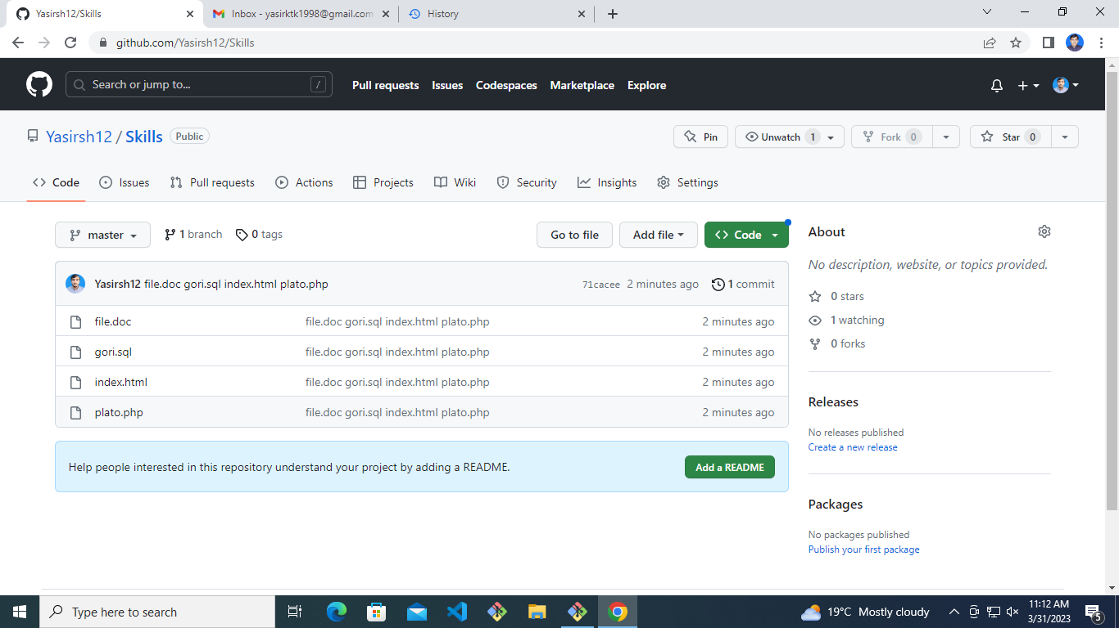$

Administrator@DESKTOP-QT517IN MINGW64 ~/Documents/VisualCode/project (master)

$ pwd

/c/Users/Administrator/Documents/VisualCode/project

Administrator@DESKTOP-QT517IN MINGW64 ~/Documents/VisualCode/project (master)

$ cd ..

Administrator@DESKTOP-QT517IN MINGW64 ~/Documents/VisualCode

$ ls

Class1/ project/

Administrator@DESKTOP-QT517IN MINGW64 ~/Documents/VisualCode

$ mkdir skills

Administrator@DESKTOP-QT517IN MINGW64 ~/Documents/VisualCode

$ ls

Class1/ project/ skills/

Administrator@DESKTOP-QT517IN MINGW64 ~/Documents/VisualCode

$ cd skills

Administrator@DESKTOP-QT517IN MINGW64 ~/Documents/VisualCode/skills

$ ls

Administrator@DESKTOP-QT517IN MINGW64 ~/Documents/VisualCode/skills

$ mkdir files images

Administrator@DESKTOP-QT517IN MINGW64 ~/Documents/VisualCode/skills

$ touch file.doc index.html plato.php gori.sql

Administrator@DESKTOP-QT517IN MINGW64 ~/Documents/VisualCode/skills

$ ls

file.doc files/ gori.sql images/ index.html plato.php

Administrator@DESKTOP-QT517IN MINGW64 ~/Documents/VisualCode/skills

$ git init

Initialized empty Git repository in C:/Users/Administrator/Documents/VisualCode/skills/.git/

Administrator@DESKTOP-QT517IN MINGW64 ~/Documents/VisualCode/skills (master)

$ git status

On branch master

No commits yet

Untracked files:

(use "git add <file>..." to include in what will be committed)

file.doc

gori.sql

index.html

plato.php

nothing added to commit but untracked files present (use "git add" to track)

Administrator@DESKTOP-QT517IN MINGW64 ~/Documents/VisualCode/skills (master)

$ git add -A

Administrator@DESKTOP-QT517IN MINGW64 ~/Documents/VisualCode/skills (master)

$ git status

On branch master

No commits yet

Changes to be committed:

(use "git rm --cached <file>..." to unstage)

new file: file.doc

new file: gori.sql

new file: index.html

new file: plato.php

Administrator@DESKTOP-QT517IN MINGW64 ~/Documents/VisualCode/skills (master)

$ git commit -m 'file.doc gori.sql index.html plato.php'

[master (root-commit) 71cacee] file.doc gori.sql index.html plato.php

4 files changed, 0 insertions(+), 0 deletions(-)

create mode 100644 file.doc

create mode 100644 gori.sql

create mode 100644 index.html

create mode 100644 plato.php

Administrator@DESKTOP-QT517IN MINGW64 ~/Documents/VisualCode/skills (master)

$ git remote add origin https://github.com/Yasirsh12/Skills.git

Administrator@DESKTOP-QT517IN MINGW64 ~/Documents/VisualCode/skills (master)

$ git push origin master

Enumerating objects: 3, done.

Counting objects: 100% (3/3), done.

Delta compression using up to 4 threads

Compressing objects: 100% (2/2), done.

Writing objects: 100% (3/3), 269 bytes | 269.00 KiB/s, done.

Total 3 (delta 0), reused 0 (delta 0), pack-reused 0

To https://github.com/Yasirsh12/Skills.git

\* [new branch] master -> master

Administrator@DESKTOP-QT517IN MINGW64 ~/Documents/VisualCode/skills (master)

$